**ETHICAL HACKING FOOTPRINTING**

# FOOTPRINTING GATHERING INFORMATION RECONNAISSANCE

### TARGET :<https://byjus.com/>

### DNS RECORDS:

### whatismyip.com

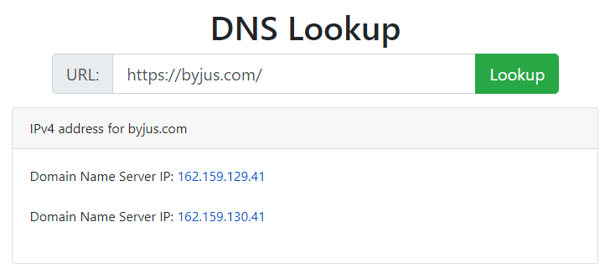

### mxtoolbox.com

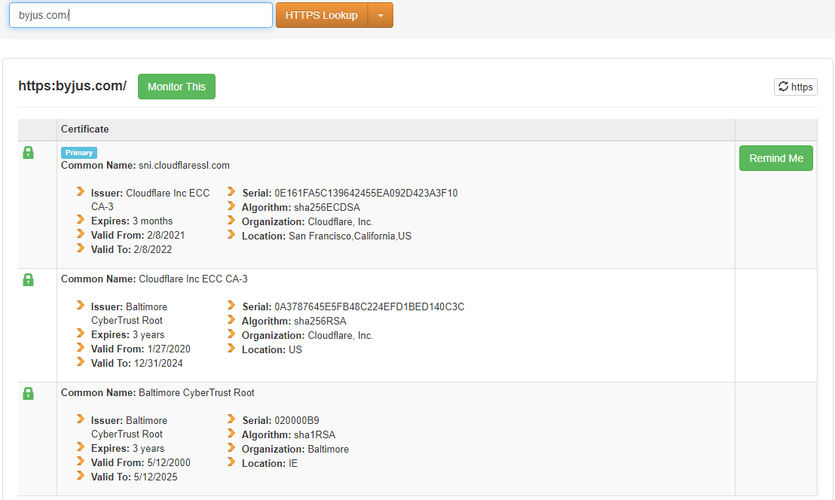

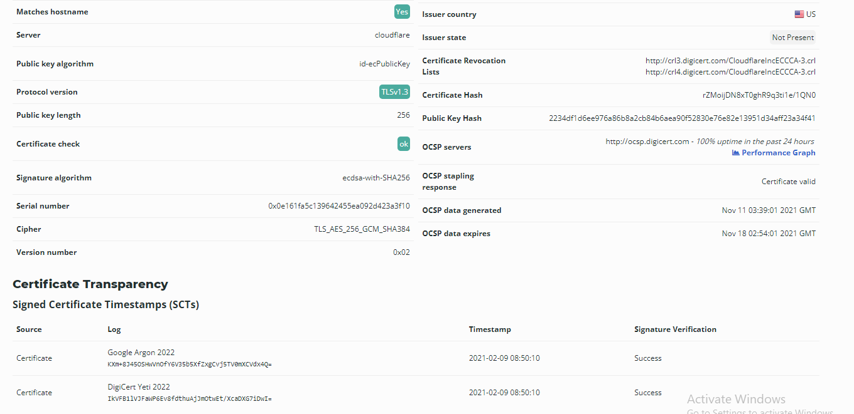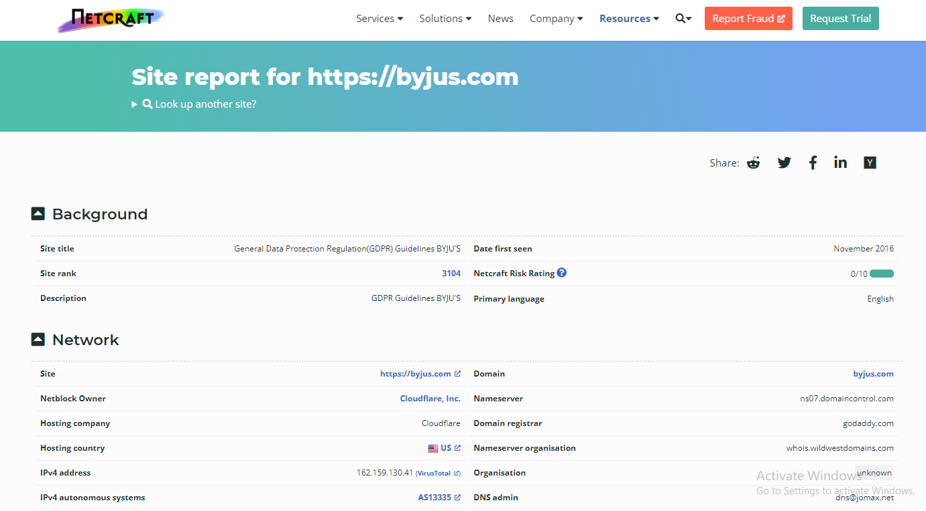

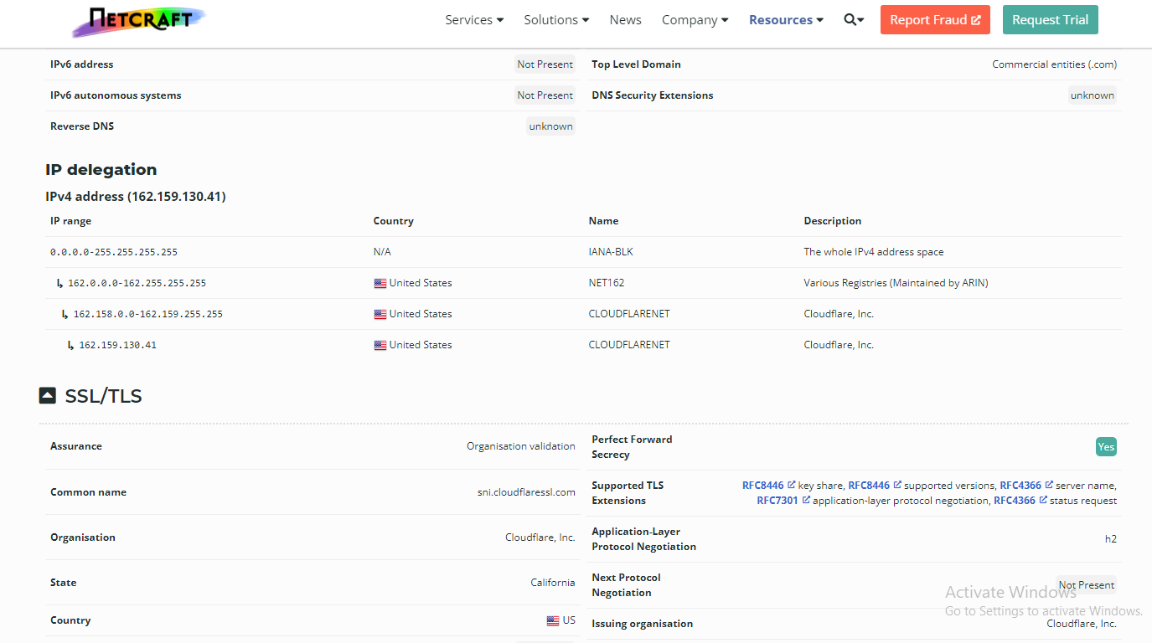

##### whois.com

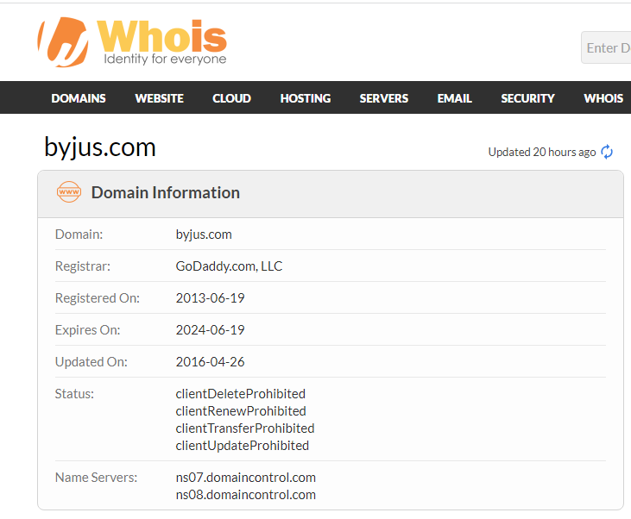

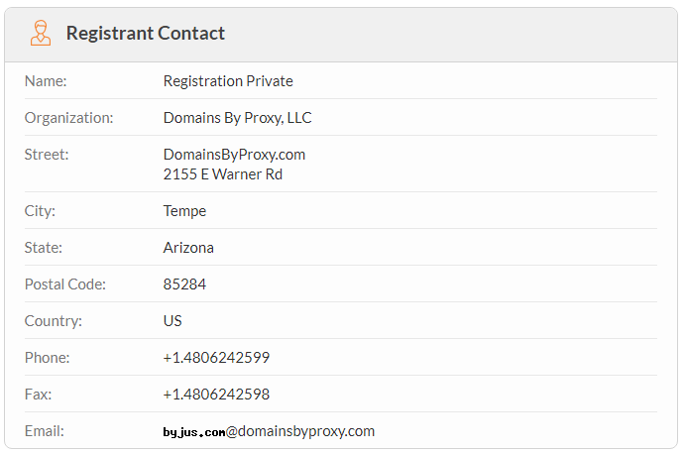

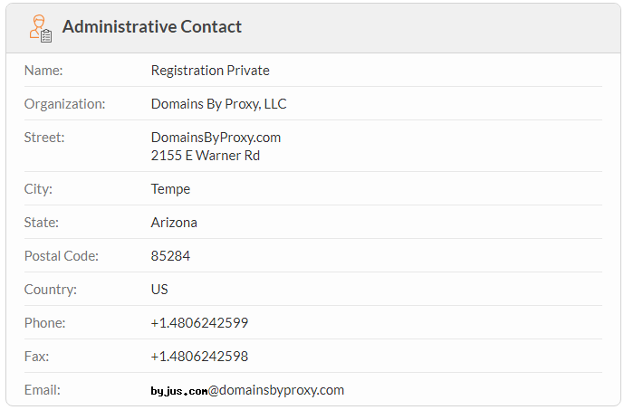

### TECHNICAL INFORMATION:

### WAPPLALYZER:



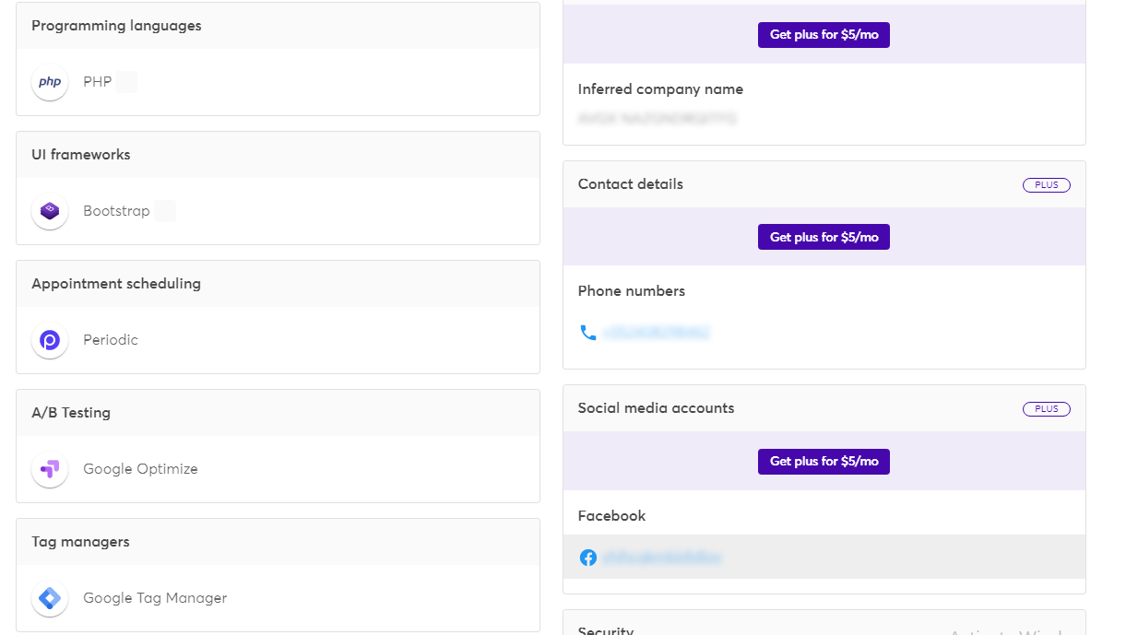

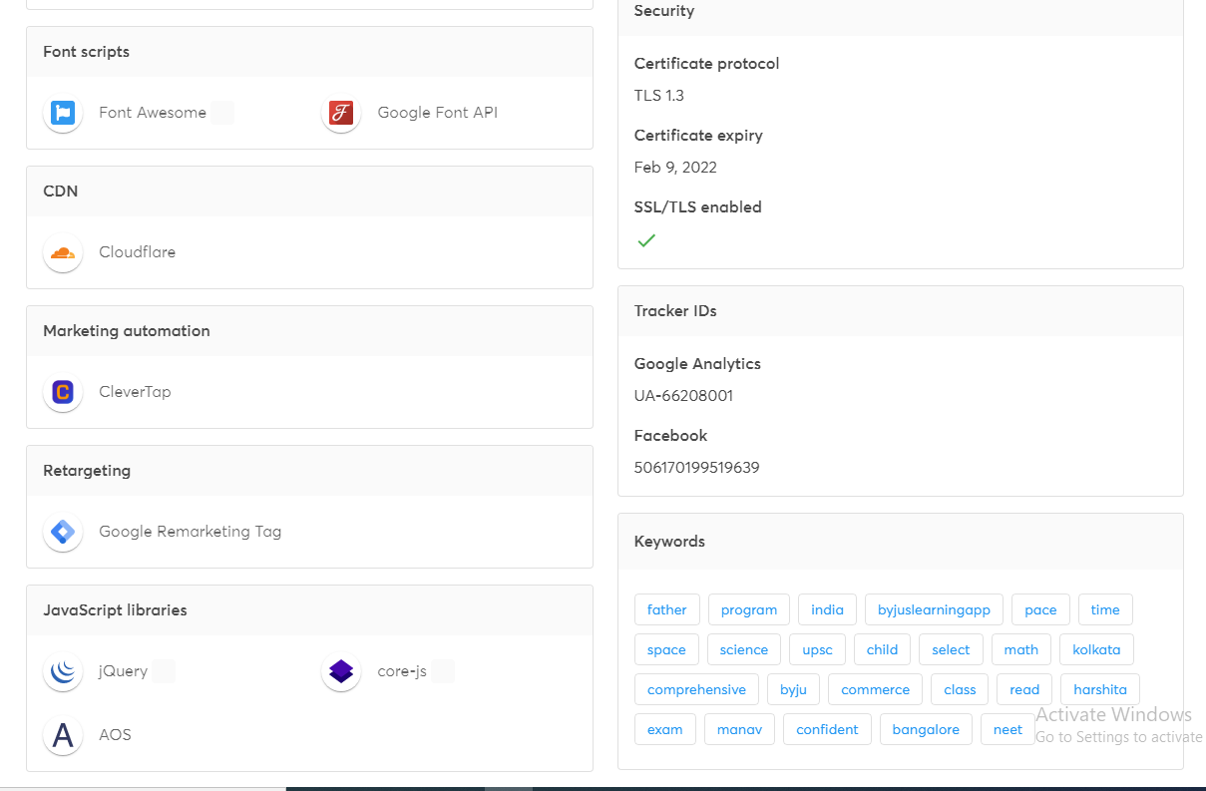

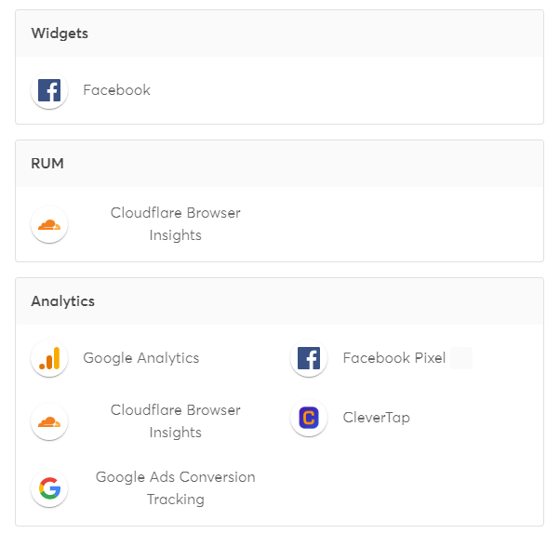

### SUBDOMAIN INFORMATION GATHERING:

### 

### 

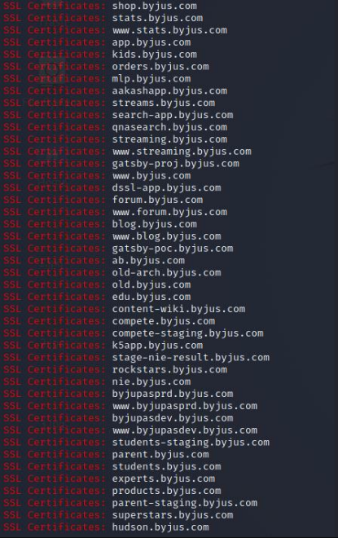

### CACHE INFORMATION:

waybackmachine(internet archive)

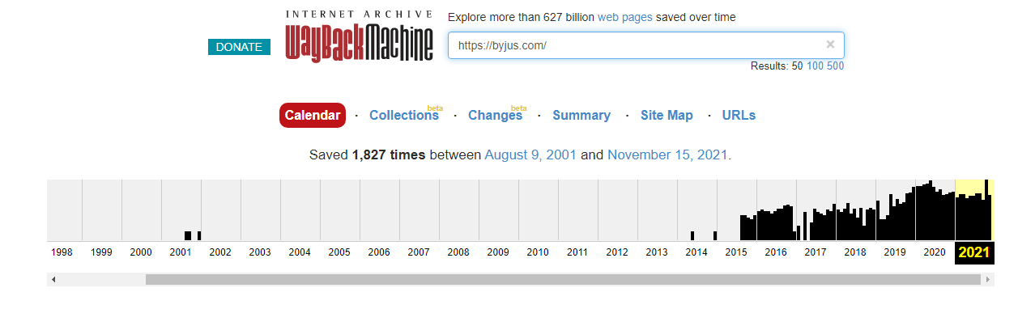IP ADDRESS INFORMATION FROM COMMAND PROMPT:

